**COLONIAL NEWS**

Health Committee Newsletter APRIL 2025

Welcome to the Albert Gallatin School District Health Committee’s monthly newsletter. Each month this publication will provide our district with health and fitness information. Our goal is for our students, families, and staff to use this information to make healthy decisions and to live a healthy active lifestyle.

**PA Harvest of the Month**

Leafy Greens

Leafy greens are plant leaves eaten as vegetables and come in a variety of tastes and textures. Many can be eaten both raw and cooked. Leafy greens include various types of lettuce (e.g. romaine, bibb, butterhead, Boston, arugula, spring mix, red leaf, green leaf, etc.) as well as spinach, Swiss chard, watercress, collard greens, mustard greens, turnip greens, and kale.

Most leafy greens are rich in many nutrients, such as vitamin A, vitamin C, antioxidants, fiber, folate (a B vitamin), vitamin K, magnesium, calcium, iron and potassium. These nutrients perform a variety of functions in the body, including promoting good vision and healthy bones, supporting immune function, acting as antioxidants that may help prevent certain cancers, and regulating blood pressure, blood sugar and blood cholesterol. (Iceberg lettuce is the exception as it is lower in nutritional value than the other leafy greens.)

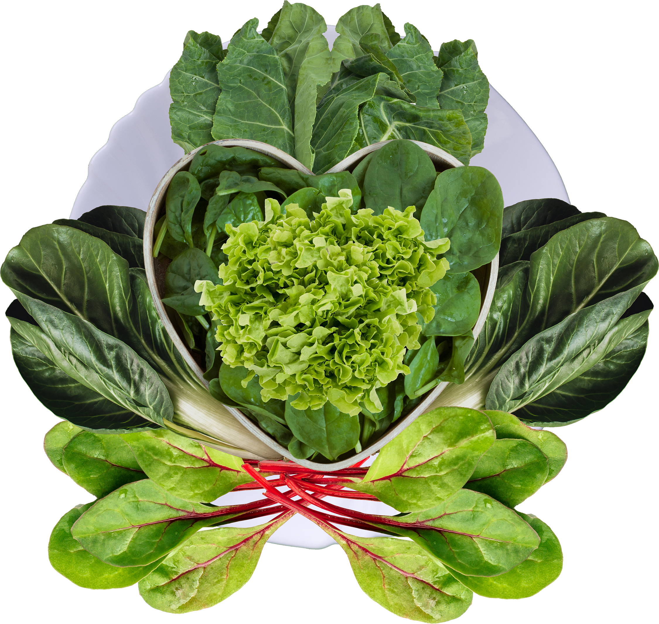

Source: https://www.paharvestofthemonth.org

## **Stress**

Stress can affect our body, thoughts, feelings, and behavior. Being able to recognize common symptoms of stress can help us manage them. Stress that's left unchecked can contribute to many health problems, such as high blood pressure, heart disease, obesity, and diabetes. Here are some tips to help relieve stress:

[Guided Imagery](https://www.verywellmind.com/use-guided-imagery-for-relaxation-3144606)

Guided imagery is like taking a short vacation in your mind by imagining yourself in your “happy place”. An example would be to close your eyes for a minute and

* think of a peaceful scene such as waves gently lapping on the shore, light filtering through the leaves of the trees
* imagine listening to the birds singing or the leaves rustling
* imagine smelling flowers, the grass, or the salt air and feeling the sun or gentle breeze on your skin.

[Progressive Muscle Relaxation](https://www.verywellmind.com/how-do-i-practice-progressive-muscle-relaxation-3024400)

This involves relaxing all the muscles in your body, group by group. Start with a few deep breaths then tighten and relax each muscle group, starting with your forehead and moving down to your toes.

Focus on Breathing

Focusing on your breathing or changing the way you breathe can make a big difference to your overall stress level. The following are a few simple suggestions:

1. Breathe in through your nose and watch your belly fill with air. Count slowly to three as you inhale. Hold for one second, and then slowly breathe out through your nose as you count to three again.
2. Breathe in through your nose and imagine that you're inhaling peaceful, calm air. Imagine that air spreading throughout your body. As you exhale, imagine that you're breathing out stress and tension.

Learning to cope with stress and finding healthy ways to deal with it can go a long way in living a healthy and positive life.

Adapted from Source: https://www.verywellmind.com/

Prepared by Lisa Sumey, Central Office Secretary

**Recipe of the Month**

Simple Spring Salad

### **Ingredients**

|  |  |
| --- | --- |
| Dressing   * 3 tbsp balsamic vinegar * 2 tbsp fresh squeezed lemon juice * 1 garlic clove, peeled and minced * 1 tsp kosher salt * 1/2 tsp black pepper * 1/4 cup extra virgin olive oil | Salad   * 1/2 red onion, sliced thin * 5 oz spring mix * 1 cup cherry tomatoes, sliced in half * 1 medium cucumber, peeled and sliced * 2-3 small radishes, sliced * 1/2 cup sunflower seeds * 1/2 cup crumbled goat cheese |

### **Instructions**

1. Mix together dressing ingredients.
2. Place sliced onion in a bowl with hot tap water and let sit for a few minutes. Drain.
3. In a large bowl, place spring mix, cherry tomatoes, cucumber slices and red onion slices. Drizzle with dressing and toss to make sure all ingredients are coated with the dressing. top with sunflower seeds and crumbled goat cheese. Serve.

Serves 4 approximately 253 calories per serving

Source: ACSHIC

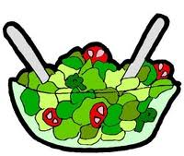

## **Healthy Banana Chocolate Chip Muffins**

   
  
  
  
   
  
 

# Walking for Wellness

Walking is one of the easiest ways to get active for most people and it’s safe, easy to stick with and low-or-no-cost and it doesn’t require any special skills or equipment.

## **Make walking part of your life**

* Start with an easy short-term goal. For example, walk for 5 or 10 minutes every day. Or increase your number of steps by 300 to 500 each day.
* Schedule walks on your daily calendar.
* Get up and move around once an hour at work.
* Take the stairs rather than the elevator.
* Walk to the grocery store, doctor appointments, work, school, or shopping when you can.

You could walk a lap around the grocery store before you start shopping.

* Park farther than usual from your workplace or a store, and walk the extra distance.
* Walk around your neighborhood or around a park.

**Be safe when you walk**

* Know your surroundings.
* Walk in a well-lighted, safe place. If it's dark, walk with a partner. Wear light-colored clothing. If you can, buy a vest or jacket that reflects light.
* Carry a cell phone for emergencies.
* Wear comfortable shoes and socks that cushion your feet.
* Pay attention to your walking surface. Use sidewalks and paths. Be careful not to slip on wet or icy ground.
* If you usually walk outside and the weather is bad, walk indoors instead. Take comfortable shoes to the mall, and walk several laps inside.
* Drink plenty of water before, during, and after you are active.

Before starting any exercise talk with your doctor to make sure they are safe for you based on your [fitness level](https://www.verywellfit.com/home-fitness-tests-3120282) and health conditions.

Adapted from Source: https://healthy.kaiserpermanente.org

